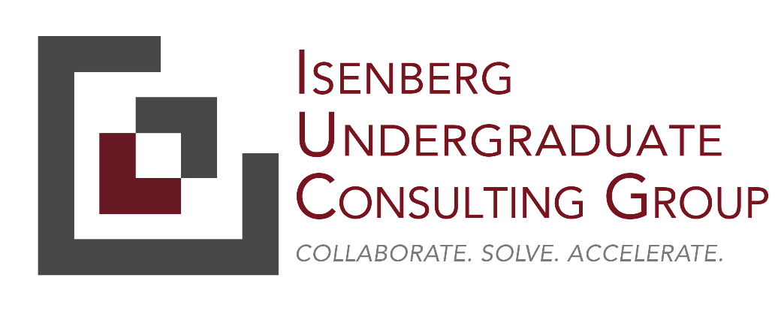

**Project *Making A Difference***

Fall 2023

|  |  |  |  |
| --- | --- | --- | --- |
| **Project Name** | *Project Making A Difference* | | |
| **IUCG Project Manager and IUCG Team** | *PM: Spencer Friedman*  *Project Director: Gabe Davis-Hollander*  *Project Team: James Stevens Ellie Zieper, Selvana Abdelmesih, Meredith Greayer, Sankalp Koripalli* | **Organization** | *Isenberg Undergraduate Consulting Group* |
| **Point(s) of Contact and Sponsor(s)** | *Primary PoC(s): Nick Ramos, Terry McCarron* | **Organization** | *Big Brothers Big Sisters of Eastern Massachusetts (BBBSEM)* |
| **Document Version and Date** | *V2: 9/14/2023* | | |
| **Engagement Period** | *September 11th, 2023 to mid-December 2023* | | |

|  |  |
| --- | --- |
| **Project Scope** | |
| **Business Need** | Since 2017, Big Brothers Big Sisters of Eastern Massachusetts (BBBSEM) has automated its communications flows with Salesforce. Over the last six years, several limitations have prevented these communications flows from reaching best-in-class status:   * **Limited expertise** contributing to strategic and tactical errors * **Staff turnover** limiting institutional knowledge and causing duplicate or low-quality communications * **Distributed ownership of processes** prevented cohesive strategic planning – if one communication or process changed, the corresponding processes or communications may not have been updated, and old versions were rarely deleted * **The COVID-19 pandemic** required rapid changes to all communications that may not have been executed perfectly or rolled back appropriately following the immediate crisis * **Changing user expectations** increased the need for personalization, use of SMS channels, and a more rapid cadence of communications * **Informal feedback structures** limited a full understanding of what was working and what wasn’t – improvements have been ad hoc as a result * **Lack of capacity** on the BBBSEM team to conduct a strategic review or implement changes   There have also been signals that BBBSEM needs an improved communications flow:   * **Decreasing conversion rate** of volunteer inquiries to interviews and eventually matches, potentially leading to as much as 50% lower conversion than ideal * **Internal feedback** from staff recognizing our communications are out of date * **External feedback** including an external review that found 100% of volunteers were confused or frustrated by their initial communications with BBBSEM   In 2023, several factors pose a unique opportunity to update these communications:   * Transitioned communications flows to a **more intuitive visualization tool** (i.e., from Salesforce workflow to Salesforce Flow) * Upgraded to a **new and improved texting vendor**, Mogli SMS * Heard **staff enthusiasm** and recognition of a need to change |
| **Project Goals** | *The objective of this engagement is to* ***complete the modernization of existing communications*** *and* ***create a new post-interview outreach process*** *for volunteers.* |
| **Project General Description** | **Phase 1: Review (~2-3 weeks)**   * BBBSEM’s database and processes are quite customized requiring dedicated time to understand. A few weeks of the project should be spent understanding:   + The volunteer and family process from first contact to match   + Understanding the different software tools we use for communicating (primarily Salesforce, FormAssembly, Acuity, and Mogli SMS)   + Auditing the communications shared with constituents   Deliverables:   * A clear map of all communications which are currently taking place, including their medium and frequency * An understanding of any design flaws in our communications   **Phase 2: Design (~4-5 weeks)**   * The aim of the design phase is to align on the future state of BBBSEM’s communication flows, including modernizing existing communications and developing a new post-interview outreach process * Sample Activities   + Catalog work to be done for modernization, including:     - Which email templates to move from Classic to Lightning layouts     - Which workflows still need to be transitioned to Salesforce Flow     - Which SMS templates are redundant and should be removed     - Which email and SMS templates have outdated language that requires updating, and what updates are most critical   + Define new post-interview outreach process, (incl. channels, cadence, and draft language)   + Plan detailed cadence for completion (e.g., objective intermediate milestones)   + List largest risks to implementation and mitigation plans for each   + Gather feedback and iterate new flows and templates with BBBSEM leaders   Deliverables:   * Finalized flows and templates ready to be implemented * Design recommendations for each of our external communications * Defined implementation plan, incl. milestones with draft timeline and risk and mitigation plans * Plan for A/B testing communication cadence and types   **Phase 3: Implementation (~4 weeks, extent TBD)**   * Depending on the state of the previous stages and the agency’s capacity to handle changes, we may opt to have the team implement all or some of the design recommendations * Sample Activities:   + Transition existing Salesforce email templates from Classic to Lightning, including updated design and wording   + Update Salesforce Flows and SMS templates   + Create and run battery of tests to confirm efficacy of all changes   + Iterate flows and templates based on feedback form Salesforce leaders   + Launch new flows and templates in Salesforce production environment   + Coach team members as needed   + Create documentation database of all changes and actions needed for maintenance   Deliverables:   * New communication templates and updated design feel of communications |
| **Out of Scope** | * N/A (can be discussed during kick-off meeting and iterated throughout the project) |
| **Success Criteria** | * Priority Goals:   + A clear map of all communications which are currently taking place, including their medium and frequency   + An understanding of any design flaws in our communications   + Finalized flows and templates ready to be implemented   + Design recommendations for each of our external communications   + Defined implementation plan, incl. milestones with draft timeline and risk and mitigation plans   + Plan for A/B testing communication cadence and types * Secondary Goals:   + New communication templates and updated design feel of communications |
| **Engagement Expectations** | * The client commits to a 1-hour weekly cadence with the IUCG team for the duration of the engagement * The client commits to 2-3 30 minutes meetings with program stakeholders (Caitlin McNee (enrollment), Erin Munroe (campus programming), Becca Feldman (site-based programming), and Constance Carmona (Big Futures Mentoring programming) * Both parties commit to replying to email communications within 48 business hours * The IUCG team commits to delivering an approximately 30-minute final deliverable presentation at the conclusion of the engagement * The client commits to completing data requests within a week after the request has been made, excluding extenuating circumstances * The client commits to taking part in a retrospective debrief approximately 1 to 2 weeks after the final deliverable presentation * The IUCG project team’s PM commits to providing a weekly email update, excluding ad-hoc communications, to the PoC covering the following: project timeline updates, agenda for the upcoming client touchpoint meeting, blockers (if any), etc. * Assuming the project objectives have been successfully completed, the client commits to offering members of the engagement team the opportunity to interview for a relevant internship position within the firm * Assuming the project objectives have been successfully completed, the client commits to producing a written testimonial of the project deliverables and the engagement experience |